A
Minor Project Report
on
Detection of speech anomalies using machine learning
Submitted for partial fulfillment for the degree of

Bachelor of Technology

(Information Technology)

in
Department of Information Technology

by

Himanshu Mittal
179302059

Under the Guidance of
Dr. Sulabh Bansal

(June-2020)

SCHOOL OF COMPUTING AND INFORMATION TECHNOLOGY

MANIPAL UNIVERSITY JAIPUR


CERTIFICATE

Date: 10/05/2020

This is to certify that the project titled DETECTION OF SPEECH ANOMALIES is a record of the bonafide work done by HIMANSHU MITTAL (179302059) submitted in partial fulfilment of the requirements for the award of the Degree of Bachelor of Technology (B.Tech) in (Information Technology) of Manipal University Jaipur, during the academic year 2014-15.

Dr. Sulabh Bansal

Project Guide, Dept of (Information Technology)

Manipal University Jaipur

Dr. Pankaj Vyas

HOD, Dept of (Information Technology.)

Manipal University Jaipur

ABSTRACT

The objective of this minor project is to predict speech anomalies in patients caused by Parkinson disease and to compare the results obtained by different machine learning algorithms.

This project has been made with the help of PRAAT software, which analyses voice samples of patients and extracts features from the voice sample. Then some machine learning techniques like k-means clustering, k-nearest neighbors, decision tree classification and support vector machine are applied on these features to predict speech anomalies

The dataset is composed of a range of biomedical voice measurements from 31 people, 23 with Parkinson's disease (PD). Each column in the table is a particular voice measure, and each row corresponds to one of 195 voice recordings from these individuals ("name" column). The main aim of the data is to discriminate healthy people from those with PD, according to the "status" column which is set to 0 for healthy and 1 for PD.

In the future, this project will help people to be aware of their problem and act on it accordingly. We can develop a machine learning model which will detect anomalies in speech. It will help people to improve their speech.

Further This project will help in the healthcare department. It will help in detection of ill health in patients. Unhealthy patients can be considered as anomaly and by using machine learning techniques we can detect anomalies in patient

LIST OF TABLES

Table No | Table Title | Page No
1. | Feature extraction of speech signal in Parkinson Disease | 35
2. | Evaluation metrics value of each model | 36

LIST OF FIGURES

Figure No | Figure Title | Page No
1 | Anomaly Detection | 3
2 | Supervised Anomaly Detection | 4
3 | Unsupervised Anomaly Detection | 4
4 | K-nearest Neighbor classification | 5
5 | K-NN classification | 7
6 | K-means clustering | 9
7 | Working of K-means algorithm | 10
8 | Vector quantization of colors into Voronoi cells using K-means | 11
9 | Un-generalized k-means example | 12
10 | A spherical cluster example and a non-spherical cluster example | 12
11 | Decision Tree example | 14
12 | Working of Decision Tree algorithm | 15
13 | n example tree that estimates the probability of kyphosis after surgery | 17
14 | relationship between Number of Neighbors (K) and Accuracy of the model | 37
15 | scatter plot between shimmer and Jitter | 37
16 | Heat map between every variable of dataset | 38
17 | Clusters of patients | 38
18 | Graph determining maximum depth of tree | 39
19 | Tree of our model | 40
20 | Gannt chart | 41

 | Contents
 | Page No
Abstract | i
List of Figures | ii
List of Tables | ii

Chapter 1 INTRODUCTION

1.1 Introduction to work done/ Motivation (Overview, Applications & Advantages) 1

1.2 Project Statement / Objectives of the Project 2

Chapter 2 BACKGROUND OVERVIEW

2.1 What is Anomaly Detection 3

2.2 Machine learning algorithms used 6

…

Chapter 3 METHODOLOGY

3.1 Detailed methodology that will be adopted 7

3.2 Praat Vocal tool kit 8
…

Chapter 4 IMPLEMENTATION AND RESULTS

4.1 Implementation of algorithms 19

4.2 Data visualization and Evaluation metrics 35

FUTURE WORK AND CONCLUSION
Chapter 5

5.1 Gannt Chart 41

5.2 Future Work and Conclusion 42

REFERENCES 43

INTRODUCTION

1.1 MOTIVATION

Currently there are many people in the world who are suffering from speech disorders and do not know the problem they are suffering from. So this project will help people to be aware of their problem and act on it accordingly. We can develop a system which will record different voices and detect anomalies in speech. It will help people to improve their speech.

Anomaly detection finds extensive use in a wide variety of applications such as fraud detection for credit cards, insurance or health care, intrusion detection for cyber-security, fault detection in safety critical systems, and military surveillance for enemy activities

I am honored to get this project on detection of speech anomalies using machine learning and with the help of this project I want to help people to be able to express their ideas more confidently

Further This project will help in the healthcare department. It will help in detection of ill health in patients. Unhealthy patients can be considered as anomaly and by using machine learning techniques we can detect anomalies in patient

1.2 PROBLEM STATEMENT

- Problem Statement- Detection of speech anomalies caused by Parkinson disease using machine learning techniques.

- The objective of project is to extract features from voice samples of patient using PRAAT software and applying different machine learning techniques on these features to predict any anomalies in speech

- General Machine learning techniques used in anomaly detection:

Neural Networks

Support Vector Machine learning

K-Nearest Neighbors Classifier

K-means Clustering Algorithm

- Machine learning techniques which can be used in detection of speech anomalies: K-Nearest Neighbors Classifier

K-means Clustering Algorithm Decision Tree classification

BACKGROUND OVERVIEW

2.1 WHAT IS ANOMALY DETECTION

Anomaly detection is a step in data mining that identifies data points, events, and/or observations that deviate from a dataset’s normal behavior. Anomalous data can indicate critical incidents, such as a technical glitch, or potential opportunities, for instance a change in consumer behavior. Machine learning is progressively being used to automate anomaly detection.
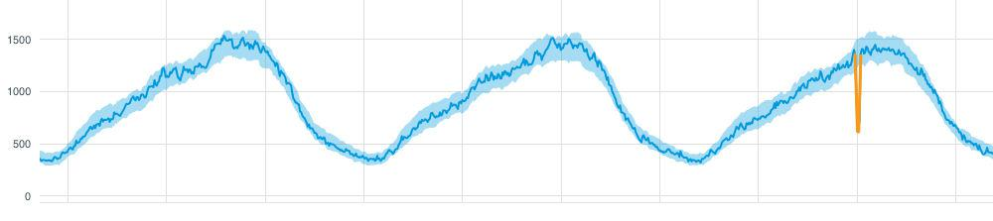

Fig-1 Anomaly Detection

This graph shows an anomalous drop detected in time series data. The anomaly is the yellow part of the line extending far below the blue shaded area, which is the normal range for this metric.

Three broad categories of anomaly detection techniques exist. Unsupervised anomaly detection techniques detect anomalies in an unlabeled test data set under the assumption that the majority of the instances in the data set are normal by looking for instances that seem to fit least to the remainder of the data set. Supervised anomaly detection techniques require a data set that has been labeled as "normal" and "abnormal" and involves training a classifier.

TYPES OF ANOMALY DETECTION TECHNIQUES

Supervised Anomaly Detection: This method requires a labeled dataset containing both normal and anomalous samples to construct a predictive model to classify future data points. The most commonly used algorithms for this purpose are supervised Neural Networks, Support Vector Machine learning, K-Nearest Neighbors Classifier, etc.
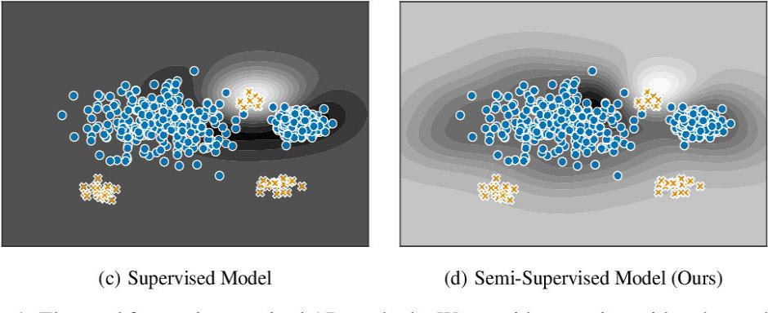

Fig-2 Supervised Anomaly detection

Unsupervised Anomaly Detection: This method does require any training data and instead assumes two things about the data ie Only a small percentage of data is anomalous and Any anomaly is statistically different from the normal samples. Based on the above assumptions, the data is then clustered using a similarity measure and the data points which are far off from the cluster are considered to be anomalies.
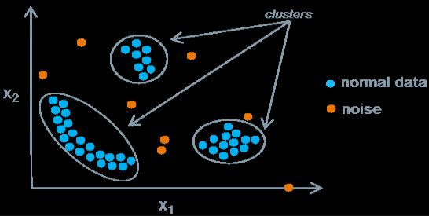

Fig-3 Unsupervised Anomaly detection

APPLICATIONS OF ANOMALY DETECTION

- Anomaly detection is applicable in a variety of domains, such as intrusion detection, fraud detection, fault detection, system health monitoring, event detection in sensor networks, and detecting ecosystem disturbances.

- It is often used in preprocessing to remove anomalous data from the dataset. In supervised learning, removing the anomalous data from the dataset often results in a statistically significant increase in accuracy.

- Application to data security

  - Anomaly detection was proposed for intrusion detection systems (IDS) by Dorothy Denning in 1986. Anomaly detection for IDS is normally accomplished with thresholds and statistics, but can also be done with soft computing, and inductive learning. Types of statistics proposed by 1999 included profiles of users, workstations, networks, remote hosts, groups of users, and programs based on frequencies, means, variances, covariance, and standard deviations.

- Anomaly Detection is used to detect anomalous records of terrorist attacks by implementing anomaly detection algorithm into a famous terrorism database-GTD to locate the anomalous records within and in doing so, the database attempt to present a list of outliers, which deviate from the rest of the data.

- Anomaly Detection is used to Identify Fraudulent Refunds with the help of classification-based and clustering-based anomaly detection techniques
2.2 ALGORITHMS USED:

K-NEAREST NEIGHBOR CLASSIFICATION

In pattern recognition, the k-nearest neighbors algorithm (k-NN) is a non-parametric method used for classification and regression. In both cases, the input consists of the k closest training examples in the feature space. The output depends on whether k-NN is used for classification or regression:

- In k-NN classification, the output is a class membership. An object is classified by a plurality vote of its neighbors, with the object being assigned to the class most common among its k nearest neighbors (k is a positive integer, typically small). If k = 1, then the object is simply assigned to the class of that single nearest neighbor.

- In k-NN regression, the output is the property value for the object. This value is the average of the values of k nearest neighbors.

k-NN is a type of instance-based learning, or lazy learning, where the function is only approximated locally and all computation is deferred until function evaluation.

Both for classification and regression, a useful technique can be to assign weights to the contributions of the neighbors, so that the nearer neighbors contribute more to the average than the more distant ones.

The neighbors are taken from a set of objects for which the class (for k-NN classification) or the object property value (for k-NN regression) is known. This can be thought of as the training set for the algorithm, though no explicit training step is required.


Fig-4 K-nearest neighbor’s classification

WORKING OF ALGORITHM

The training examples are vectors in a multidimensional feature space, each with a class label. The training phase of the algorithm consists only of storing the feature vectors and class labels of the training samples.

In the classification phase, k is a user-defined constant, and an unlabeled vector (a query or test point) is classified by assigning the label, which is most frequent among the k training samples nearest to that query point.

A commonly used distance metric for continuous variables is Euclidean distance. For discrete variables, such as for text classification, another metric can be used, such as the overlap metric (or Hamming distance). In the context of gene expression microarray data, for example, k-NN has been employed with correlation coefficients, such as Pearson and Spearman, as a metric.

Often, the classification accuracy of k-NN can be improved significantly if the distance metric is learned with specialized algorithms such as Large Margin Nearest Neighbor or Neighborhood components analysis.

A drawback of the basic "majority voting" classification occurs when the class distribution is skewed. That is, examples of a more frequent class tend to dominate the prediction of the new example, because they tend to be common among the k nearest neighbors due to their large number. One way to overcome this problem is to weight the classification, taking into account the distance from the test point to each of its k nearest neighbors. The class (or value, in regression problems) of each of the k nearest points is multiplied by a weight proportional to the inverse of the distance from that point to the test point.
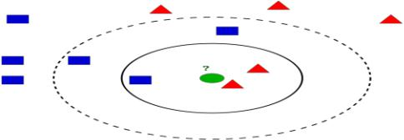

Fig-5 K-NN classification

Example of k-NN classification. The test sample (green dot) should be classified either to blue squares or to red triangles. If k = 3 (solid line circle) it is assigned to the red triangles because there are 2 triangles and only 1 square inside the inner circle.

ADVANTAGES OF K-NEAREST NEIGHBOR

- K-NN is pretty intuitive and simple: K-NN algorithm is very simple to understand and equally easy to implement. To classify the new data point K-NN algorithm reads through the whole dataset to find out K nearest neighbors.

- K-NN has no assumptions: K-NN is a non-parametric algorithm, which means there are assumptions to be met to implement K-NN. Parametric models as if linear regression have many assumptions to be met by data before it can be implemented which is not the case with K-NN.

- No Training Step: K-NN does not explicitly build any model, it simply tags the new data entry based learning from historical data.

DISADVANTAGES OF K-NEAREST NEIGHBOR

- K-NN slow algorithm: K-NN might be very easy to implement but as the dataset grows efficiency or speed of algorithm declines very fast.

- Curse of Dimensionality: KNN works well with a small number of input variables but as the numbers of variables grow K-NN algorithm struggles to predict the output of new data points.

K-MEANS CLUSTERING ALGORITHM

Clustering is one of the most common exploratory data analysis techniques used to get an intuition about the structure of the data. It can be defined as the task of identifying subgroups in the data such that data points in the same subgroup (cluster) are very similar while data points in different clusters are very different. In other words, we try to find homogeneous subgroups within the data such that data points in each cluster are as similar as possible according to a similarity measure such as Euclidean-based distance or correlation-based distance. The decision of which similarity measure to use is application specific.

Clustering analysis can be done based on features where we try to find subgroups of samples based on features or based on samples where we try to find subgroups of features based on samples. We will cover here clustering based on features. Clustering is used in market segmentation; where we try to find customers that are similar to each other whether in terms of behaviors or attributes, image segmentation/compression; where we try to group similar regions together, document clustering based on topics, etc.
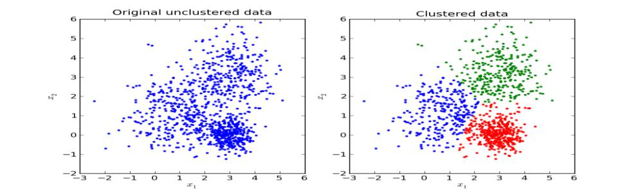

Fig-6 K-means clustering

WORKING OF ALGORITHM

K-Means algorithm is an iterative algorithm that tries to partition the dataset into k pre-defined distinct non-overlapping subgroups (clusters) where each data point belongs to only one group. It tries to make the intra-cluster data points as similar as possible while also keeping the clusters as different (far) as possible. It assigns data points to a cluster such that the sum of the squared distance between the data points and the cluster’s centroid is at the minimum. The less variation we have within clusters, the more homogeneous (similar) the data points are within the same cluster.

The way k-means algorithm works is as follows:

- Specify number of clusters K.

- Initialize centroids by first shuffling the dataset and then randomly selecting K data points for the centroids without replacement.

- Keep iterating until there is no change to the centroids. i.e assignment of data points to clusters isn’t changing.

  - Compute the sum of the squared distance between data points and all centroids and assign each data point to the closest cluster (centroid).

  - Compute the centroids for the clusters by taking the average of the all data points that belong to each cluster.
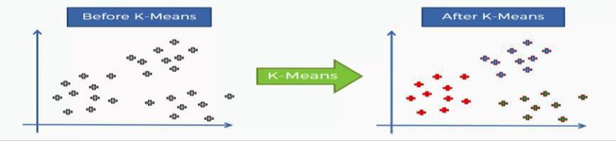

Fig-7 Working of algorithm

APPLICATIONS

K--means clustering algorithm has been successfully used in market segmentation, computer vision, and astronomy among many other domains. It often is used as a preprocessing step for other algorithms, for example to find a starting configuration.

Vector quantization

K-means originates from signal processing, and still finds use in this domain. For example, in computer graphics, color quantization is the task of reducing the color palette of an image to a fixed number of colors k. The k-means algorithm can easily be used for this task and produces competitive results. A use case for this approach is image segmentation. Other uses of vector quantization include non-random sampling, as k-means can easily be used to choose k different but prototypical objects from a large data set for further analysis.
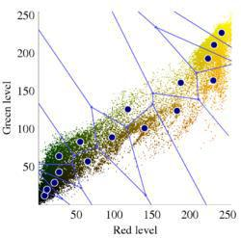

Fig- 8 Vector quantization of colors present in the image above into Voronoi cells using K-means.

Cluster analysis

In cluster analysis, the k-means algorithm can be used to partition the input data set into k partitions (clusters).

However, the pure k-means algorithm is not very flexible, and as such is of limited use (except for when vector quantization as above is actually the desired use case). In particular, the parameter k is known to be hard to choose (as discussed above) when not given by external constraints.

ADVANTAGES OF K-MEANS CLUSTERING

- Relatively simple to implement.

- Scales to large data sets.

- Guarantees convergence.

- Generalizes to clusters of different shapes and sizes, such as elliptical clusters.

K-means Generalization

What happens when clusters are of different densities and sizes? Look at Figure 1. Compare the intuitive clusters on the left side with the clusters actually found by k-means on the right side. The comparison shows how k-means can stumble on certain datasets.
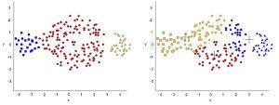

Fig-9 Un generalized k-means example.

To cluster naturally imbalanced clusters like the ones shown in Figure 1, you can adapt (generalize) k-means. In Figure 2, the lines show the cluster boundaries after generalizing k-means as:

- Left plot: No generalization, resulting in a non-intuitive cluster boundary.

- Center plot: Allow different cluster widths, resulting in more intuitive clusters of different sizes.

- Right plot: Besides different cluster widths, allow different widths per dimension, resulting in elliptical instead of spherical clusters, improving the result.
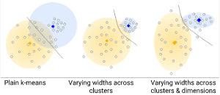

Fig- 10 A spherical cluster example and a non-spherical cluster example.

DISADVANTAGES OF K-MEANS CLUSTERING

- Being dependent on initial values.

For a low k, you can mitigate this dependence by running k-means several times with different initial values and picking the best result. as k increases, you need advanced versions of k-means to pick better values of the initial centroids.

- Clustering data of varying sizes and density.

K-means has trouble clustering data where clusters are of varying sizes and density. To cluster such data, you need to generalize k-means

- Clustering outliers.

Outliers can drag centroids, or outliers might get their own cluster instead of being ignored. Consider removing or clipping outliers before clustering.

- Scaling with a number of dimensions.

As the number of dimensions increases, a distance-based similarity measure converges to

a constant value between any given examples. Either reduce dimensionality by using PCA on the feature data, or by using “spectral clustering”, to modify the clustering
algorithm as explained below.

DECISION TREE CLASSIFICATION

Decision trees build regression or classification models in the form of a tree structure. It breaks down a dataset into smaller and smaller subsets while at the same time an associated decision tree is incrementally developed. The result is a tree with decision nodes and leaf nodes. A decision node (e.g., Outlook) has two or more branches (e.g., Sunny, Overcast and Rainy), each representing values for the attribute tested. Leaf node (e.g., Hours Played) represents a decision on the numerical target. The topmost decision node in a tree, which corresponds to the best predictor, called root node. Decision trees can handle both categorical and numerical data.
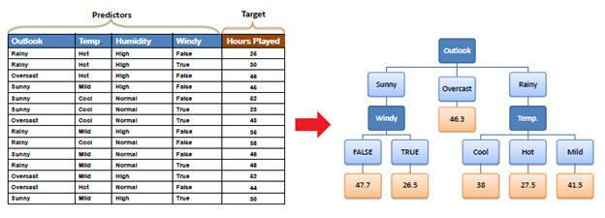

Fig-11 Decision tree example

APPLICATIONS:

- Predicting high occupancy dates for hotels

- Identifying factors leading to better gross margins on a retail chain (curious: # of drugstores nearby was particularly effective for this client)

- Identifying correlates to high average checks for a global quick-service restaurant chain

- Classification system for serial criminal patterns (CSSCP) - using three years' worth of data on armed robbery, the system was able to spot 10 times as many patterns as a team of experienced detectives with access to the same data.
WORKING OF ALGORITHM

- Place the best attribute of the dataset at the root of the tree.

- Split the training set into subsets. Subsets should be made in such a way that each subset contains data with the same value for an attribute.

- Repeat step 1 and step 2 on each subset until you find leaf nodes in all the branches of the tree.
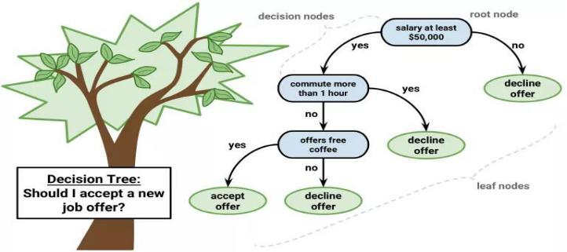

Fig-12 Working of algorithm

In decision trees, for predicting a class label for a record we start from the root of the tree. We compare the values of the root attribute with the record's attribute. Based on comparison, we follow the branch corresponding to that value and jump to the next node.

We continue comparing our record’s attribute values with other internal nodes of the tree until we reach a leaf node with predicted class value. As we know how the modeled decision tree can be used to predict the target class or the value. Now let us understand how we can create the decision tree model.

Assumptions while creating Decision Tree

Below are the some of the assumptions we make while using Decision tree:

- At the beginning, the whole training set is considered as the root.

- Feature values are preferred to be categorical. If the values are continuous then they are discretized prior to building the model.

- Records are distributed recursively based on attribute values.

- Order to place attributes as the root or internal node of the tree is done by using some statistical approach.
Decision tree types

Decision trees used in data mining are of two main types:

- Classification tree analysis is when the predicted outcome is the class (discrete) to which the data belongs.

- Regression tree analysis is when the predicted outcome can be considered a real number (e.g. the price of a house, or a patient's length of stay in a hospital).

The term Classification and Regression Tree (CART) analysis is an umbrella term used to refer to both of the above procedures, first introduced by Breiman et al. in 1984. Trees used for regression and trees used for classification have some similarities - but also some differences, such as the procedure used to determine where to split.

Some techniques, often called ensemble methods, construct more than one decision tree:

- Boosted trees incrementally building an ensemble by training each new instance to emphasize the training instances previously mis-modeled. A typical example is AdaBoost. These can be used for regression-type and classification-type problems.

- Bootstrap aggregated (or bagged) decision trees, an early ensemble method, builds multiple decision trees by repeatedly resampling training data with replacement, and voting the trees for a consensus prediction. A random forest classifier is a specific type of bootstrap aggregating.

- Rotation forest – in which every decision tree is trained by first applying principal component analysis (PCA) on a random subset of the input features.

A special case of a decision tree is a decision list, which is a one-sided decision tree, so that every internal node has exactly 1 leaf node and exactly 1 internal node as a child (except for the bottommost node, whose only child is a single leaf node). While less expressive, decision lists are arguably easier to understand than general decision trees due to their added sparsity, permit non-greedy learning methods and monotonic constraints to be imposed.
Decision tree learning is the construction of a decision tree from class-labeled training tuples. A decision tree is a flow-chart-like structure, where each internal (non-leaf) node denotes a test on an attribute, each branch represents the outcome of a test, and each leaf (or terminal) node holds a class label. The topmost node in a tree is the root node.

There are many specific decision-tree algorithms. Notable ones include:

- ID3 (Iterative Dichotomies 3)

- C4.5 (successor of ID3)

- CART (Classification and Regression Tree)

- MARS: extends decision trees to handle numerical data better.

- Conditional Inference Trees. Statistics-based approach that uses non-parametric tests as splitting criteria, corrected for multiple testing to avoid overfitting. This approach results in unbiased predictor selection and does not require pruning
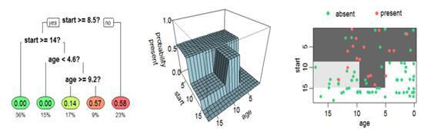

Fig-13 an example tree that estimates the probability of kyphosis after surgery

An example tree, which estimates the probability of kyphosis after surgery, given the age of the patient, and the vertebra at which surgery was started. The same tree is shown in three different ways. The colored leaves show the probability of kyphosis after surgery, and percentage of patients in the leaf. Middle the tree as a perspective plot. Right Aerial view of the middle plot. The probability of kyphosis after surgery is higher in the darker areas

METHODOLOGY

3.1 DETAILED METHODOLOGY

- We can now demonstrate the process of anomaly detection on a synthetic dataset using the K-Nearest Neighbors, K-means clustering and decision tree classification

- We have to first collect different voice samples from healthy patients and patients suffering from Parkinson disease

- Next step is to apply different machine learning techniques to predict any speech anomalies

- we can use any two machine learning techniques and compare the predictions and model’s accuracy analysis given by both techniques

- We have to use PRAAT vocal kit to analysis different voices and provide output

3.2 PRAAT VOCAL KIT

- PRAAT is a freeware program for the analysis and reconstruction of acoustic speech signals.

- PRAAT is a software that extracts features from different voices and provides output.

- Different machine learning algorithms are used on the output provided by PRAAT to detect anomalies.

- PRAAT is a very flexible tool to do speech analysis. It offers a wide range of standard and non-standard procedures, including spectrographic analysis, articulatory synthesis, and neural networks

IMPLEMENTATION AND RESULT

4.1 IMPLEMENTATION OF MACHINE LEARNING ALGORITHMS:

IMPORTING REQUIRED LIBRARIES

Before we can import our dataset and perform analysis, we need to import a few libraries. The following script is used to import libraries:
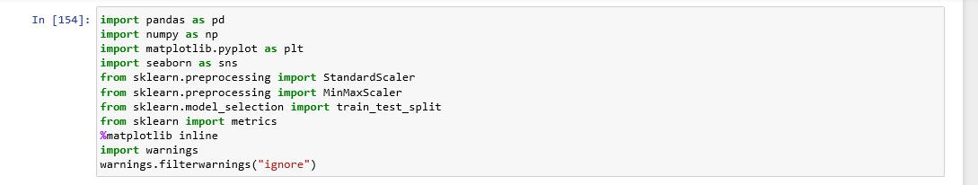

LOADING THE DATASET

Once we import the libraries, the next step is to load the dataset into our application. To do so, we used the “read_csv ()” function of the Pandas library, which reads dataset that is in the CSV format

The following script loads the dataset into “parkinson.csv” data frame:
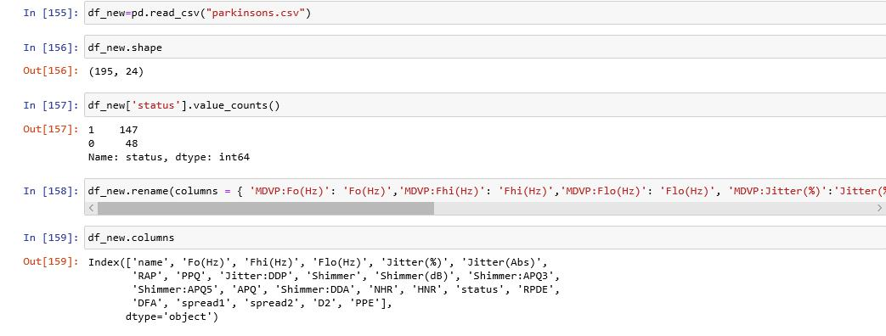

DATA ANALYSIS

To see how the dataset actually looks, we can use the “head ()” function of the Pandas data frame and to see the statistical details of data, we can use “describe ()” function of pandas data frame:

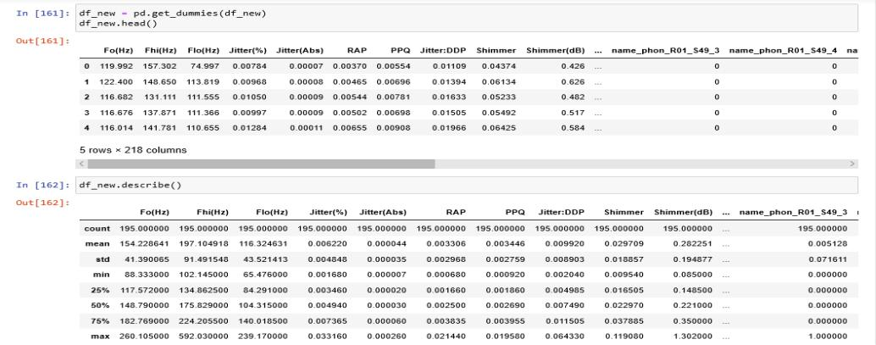

DATA PREPROCESSING AND TRAINING/TESTING DATASET

We will segregate the variables into x and y using the preprocessing library of sklearn and apply train_test_split on x and y to train the dataset. We will also normalize the values of x variable to make the scale of each value equal.
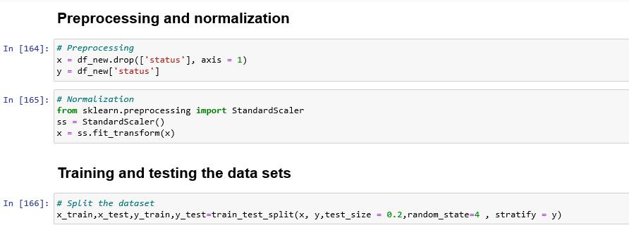
K-NEAREST NEIGHBOR CLASSIFICATION

SELECTING THE BEST K-VALUE
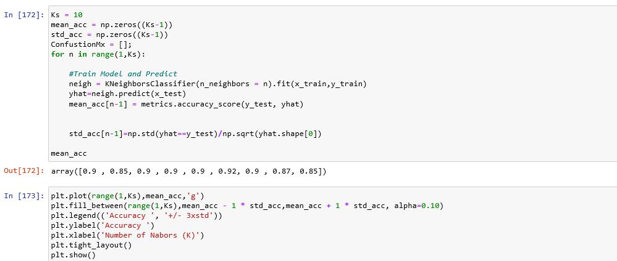
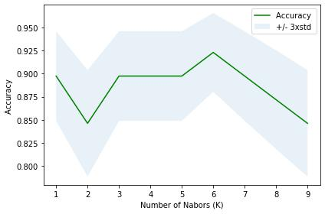

This graph shows that at the k=6, the accuracy of model is highest, which implies that k=6 should be selected for prediction of model
BUILDING A MODEL AND EVALUATION METRICS

We will build the model by importing K-nearest neighbors from neighbor’s library in sklearn and then by creating an object of it and fitting the train data into this model. Then we will predict the outcomes of model using “predict” function. After this we will calculate accuracy of train and test data using “accuracy score” metric and f1_score using “f1_score” metric
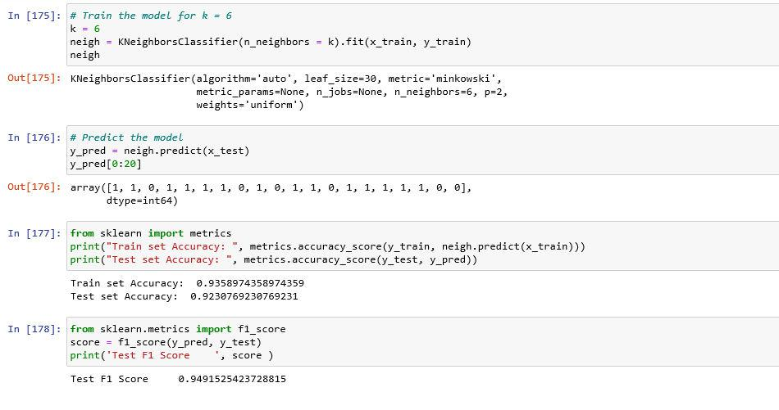
CONFUSION MATRIX
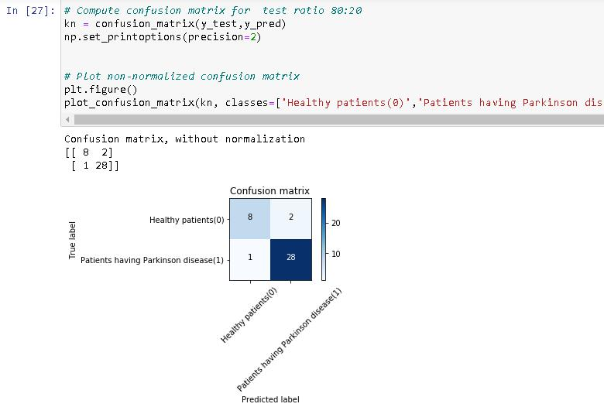
ROC CURVE
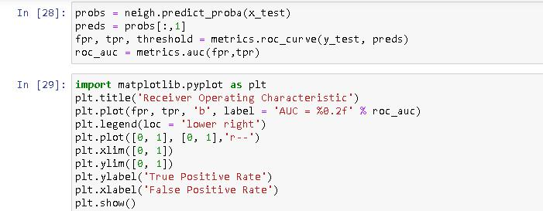
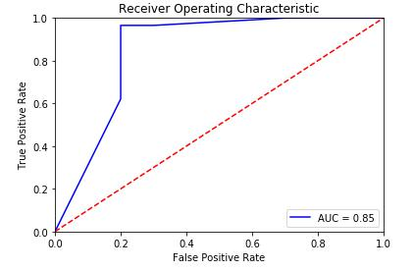

- This is the ROC curve between True positive rate and False positive rate

- Area under curve is 0.85
DATA VISUALIZATION

We will visualize our data using some of matplotlib techniques
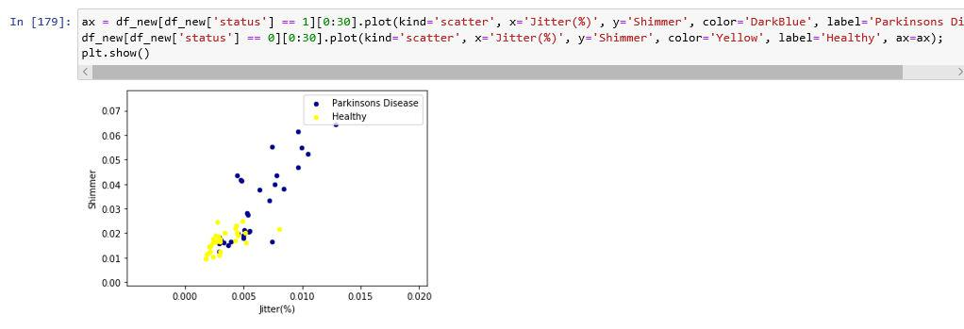

This is a 2-D scatter plot between shimmer and Jitter (%) and differentiates healthy patients from patients suffering from Parkinson disease.
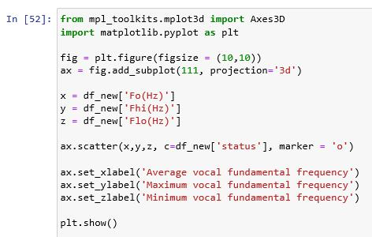
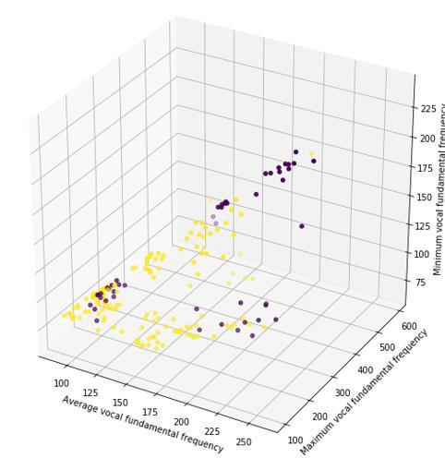

This is a 3-D scatter plot between Maximum vocal fundamental frequency, Minimum voice fundamental and Average voice fundamental frequency. In this plot, yellow denotes patients having Parkinson disease and purple denotes healthy patients
K-MEANS CLUSTERING

FINDING THE BEST CLUSTERS
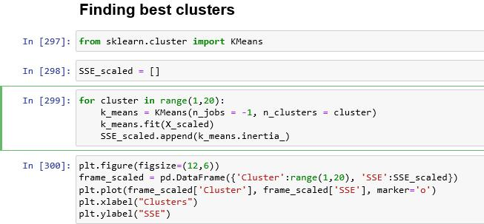
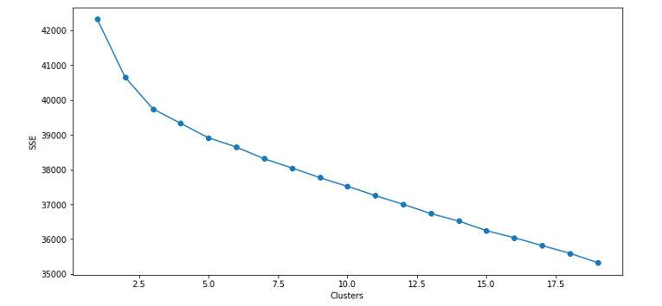

This graph shows the absolute value of clusters. As the inertia drops down at 3 and then becomes constant, so cluster value 3 is selected for the model
BUILDING MODEL AND EVALUATION METRIC

We will build the model by importing K-means clustering from cluster library in sklearn and then by creating an object of it and fitting the train data into this model. Then we will predict the outcomes of model using “predict” function. After we will calculate inertia of clusters using “inertia_” metrics
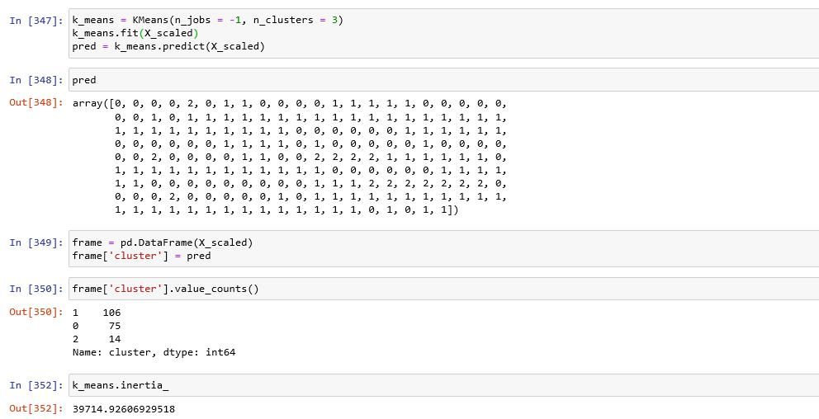
DATA VISUALIZATION

We will visualize our data and clusters using matplotlib and seaborne techniques
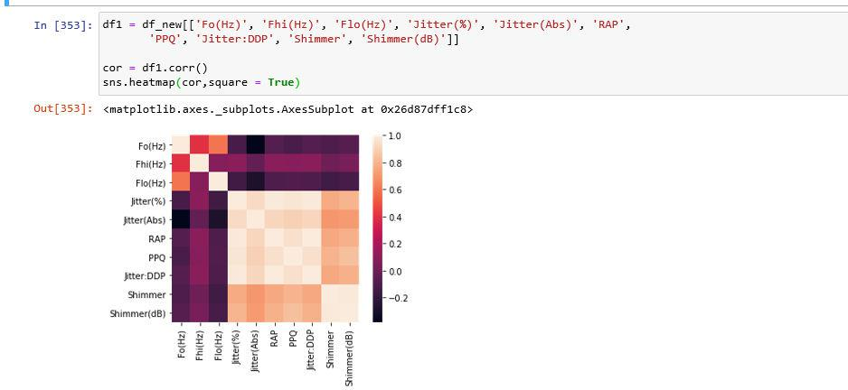

Above figure shows heat map between different variables of our data
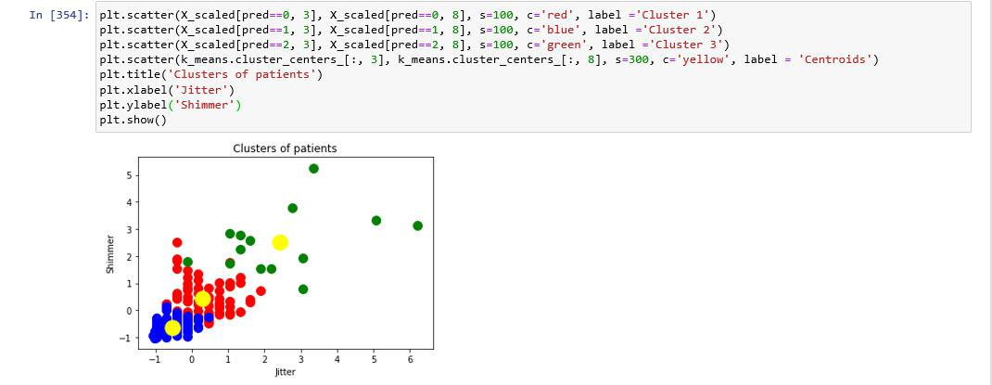

Above figure shows our data divided into 3 clusters

DECISION TREE CLASSIFICATION

SELECTING APPROPRIATE MAXIMUM DEPTH OF TREE
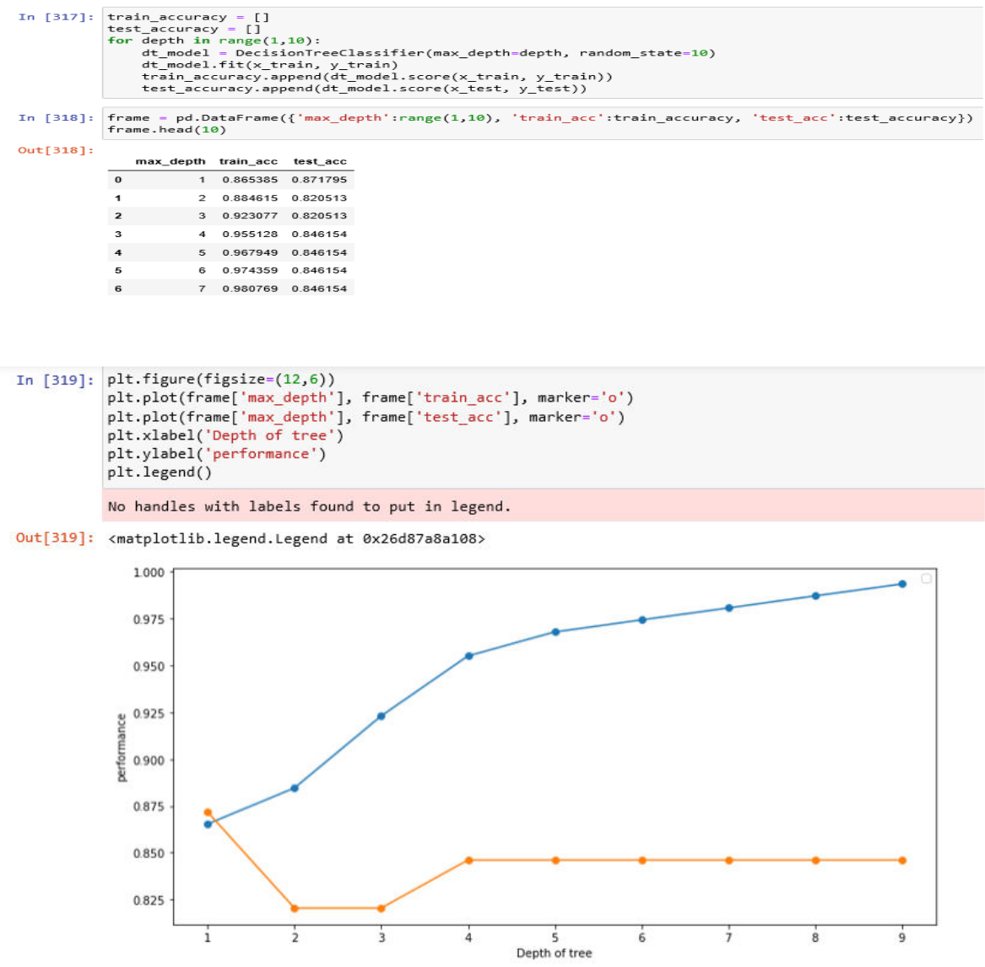

This graph shows the curve of train and test set accuracy when set to a particular depth. This model’s performance becomes high at depth 8, so a 8 is selected as maximum depth of tree
BUILDING A MODEL

We will build the model by importing Decision Tree classification from tree library in sklearn and then by creating an object of it and fitting the train data into this model.
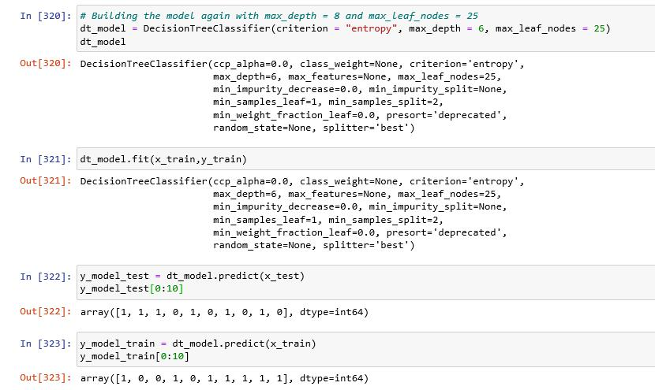
EVALUATION METRICS

We will calculate the evaluation metrics of model using these metrics:

Accuracy
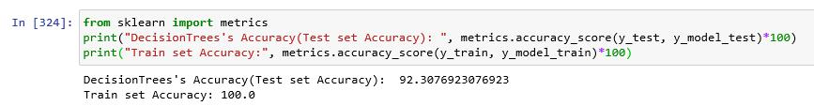

Confusion matrix
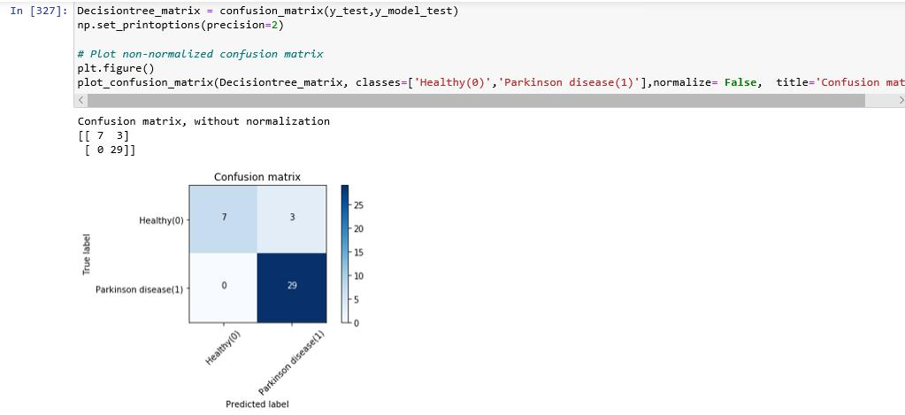
ROC CURVE
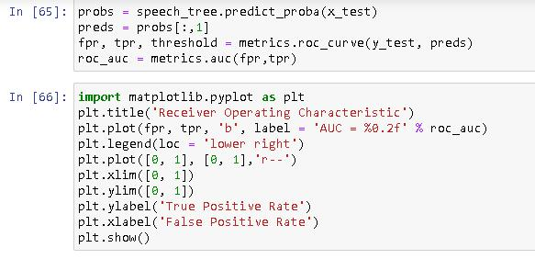
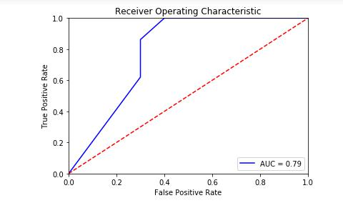

- This is the ROC curve between True positive rate and False positive rate

- Area under the curve is 0.79

DATA VISUALIZATION

We will visualize our data using graphviz package

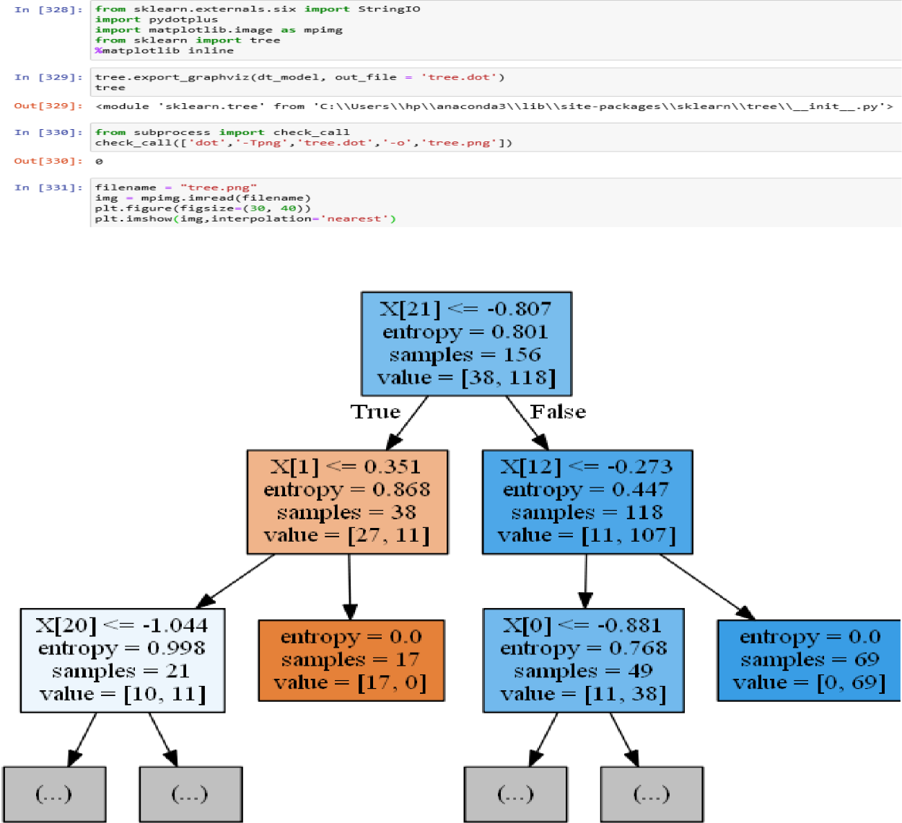

DECISION TREE OF OUR MODEL

4.2 DATA VISUALIZATION AND EVALUATION METRICS

Spectral analysis and feature extraction of speech signal in Parkinson disease

Name | Fo (Hz) | Fhi (Hz) | Flo (Hz) | Jitter (%) | Jitter(Abs) | Shimmer (%) | Shimmer(dB) | Status
Patient 1 | 119.992 | 157.302 | 74.997 | 0.00784 | 0.00007 | 0.04374 | 0.426 | 1
Patient 2 | 122.4 | 148.65 | 113.819 | 0.00968 | 0.00008 | 0.06134 | 0.626 | 1
Patient 3 | 116.682 | 131.111 | 111.555 | 0.0105 | 0.00009 | 0.05233 | 0.482 | 1
Patient 4 | 197.076 | 206.896 | 192.055 | 0.00289 | 0.00001 | 0.01098 | 0.097 | 0
Patient 5 | 199.228 | 209.512 | 192.091 | 0.00241 | 0.00001 | 0.01015 | 0.089 | 0
Patient 6 | 198.383 | 215.203 | 193.104 | 0.00212 | 0.00001 | 0.01263 | 0.111 | 0

TABLE-1

Fo (Hz): Average vocal fundamental frequency

Fhi (Hz): Maximum vocal fundamental frequency

Flo (Hz): Minimum vocal fundamental frequency

Jitter (%), Jitter (Abs): Several measures of variation in fundamental frequency

Shimmer, Shimmer (dB): Several measures of variation in amplitude

Status: Health status of the subject (one) - Parkinson's, (zero) - healthy

- The aim and objective of this study is to compare the acoustic voice parameters obtained from the PRAAT software and automated feature-extracted parameters in normal and Parkinson patients.

- The speech signal is recorded and acoustic features were extracted using the PRAAT software. Using the PRAAT software, the jitter (%) values were found to be 0.002473 and 0.00934 for the normal and Parkinson patients respectively.

- The shimmer (%) values obtained for the normal and Parkinson patients as 0.01125 and 0.05247 respectively.

- In conclusion, the acoustic parameters measured from the speech signal using both the
PRAAT software shows significantly increased values in Parkinson patients compared to normal patients
Evaluation metrics value of each model

Evaluation metrics | K-Nearest Neighbors | K-Means Clustering | Decision Tree Classification
Accuracy of test data | 93.5897435 | NA | 92.307692
Accuracy of train data | 92.30769235 | NA | 100.0
F1 Score | 0.949152567 | NA | 0.9508196
Inertia | NA | 39722.17934 | NA
Silhouette score | NA | 0.018930962 | NA

TABLE-2

- From the above table we can see that accuracy of K-nearest neighbors is greater than the accuracy of Decision Tree Classification, so we can conclude from this observation that K-nearest neighbor is a better model among the three.

- Training accuracy is the accuracy you get if you apply the model on the training data, while Testing accuracy is the accuracy for the testing data.

  - Higher accuracy of testing data always results in a better model

- F1 score : In statistical analysis of binary classification, the F₁ score (also F-score or F-measure) is a measure of a test's accuracy

  - The F₁ score is the harmonic mean of the precision and recall, where an F₁ score reaches its best value at 1 (perfect precision and recall). The F₁ score is also known as Dice similarity coefficient (DSC).
  - A good F1 score is approx. to 1(perfect precision and recall)

- Inertia is the sum of squared error for each cluster. Therefore, the smaller the inertia the denser the cluster. The Silhouette Score is from -1 to 1 and shows how close or far away the clusters are from each other and how dense the clusters are.
Data visualization of each model

- K-nearest neighbor

Fig-14 relationship between Number of Neighbors (K) and Accuracy of the model

Above graph shows the relationship between Number of Neighbors (K) and Accuracy of the model according to each neighbor. This is done to select the best value of k to build k-nearest neighbor model. K=6 is selected in this case because the accuracy of model at 6 is the highest which in turn results in a better model
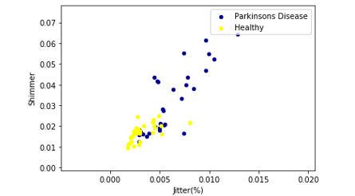

Fig-15 scatter plot between shimmer and Jitter

This is 2-D scatter plot between Shimmer values and Jitter values. The data points are scattered based on values of shimmer, jitter, “yellow” color denotes healthy patient, and “blue” color denotes Patients suffering from Parkinson disease

- K-Means Clustering
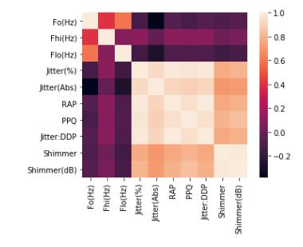

Fig-16 Heat map between every variable of dataset

This is a heat map of correlation between every variable of dataset and the highest correlation is between Jitter (%) and Shimmer, which is around 0.8
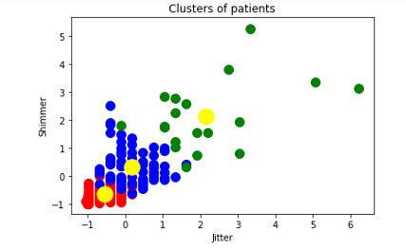

Fig-17 Clusters of patients

The dataset is divided into 3 clusters (0,1,2) and the centroid of each cluster is calculated and plotted. Due to low value of inertia, we can see that the cluster is denser (i.e. All the points are closer together)

- Decision Tree classification
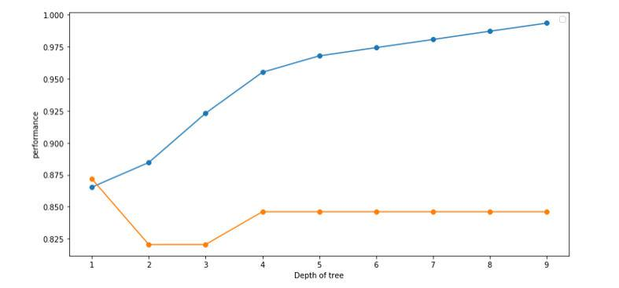

Fig-18 Graph determining maximum depth of tree

This graph determines the maximum depth of the tree. The performance of the tree increases at 4 and then becomes constant until 8 after which it slightly increases at 9. Therefore, from this observation, we conclude that we should take maximum depth as 8 to give good predictions in future

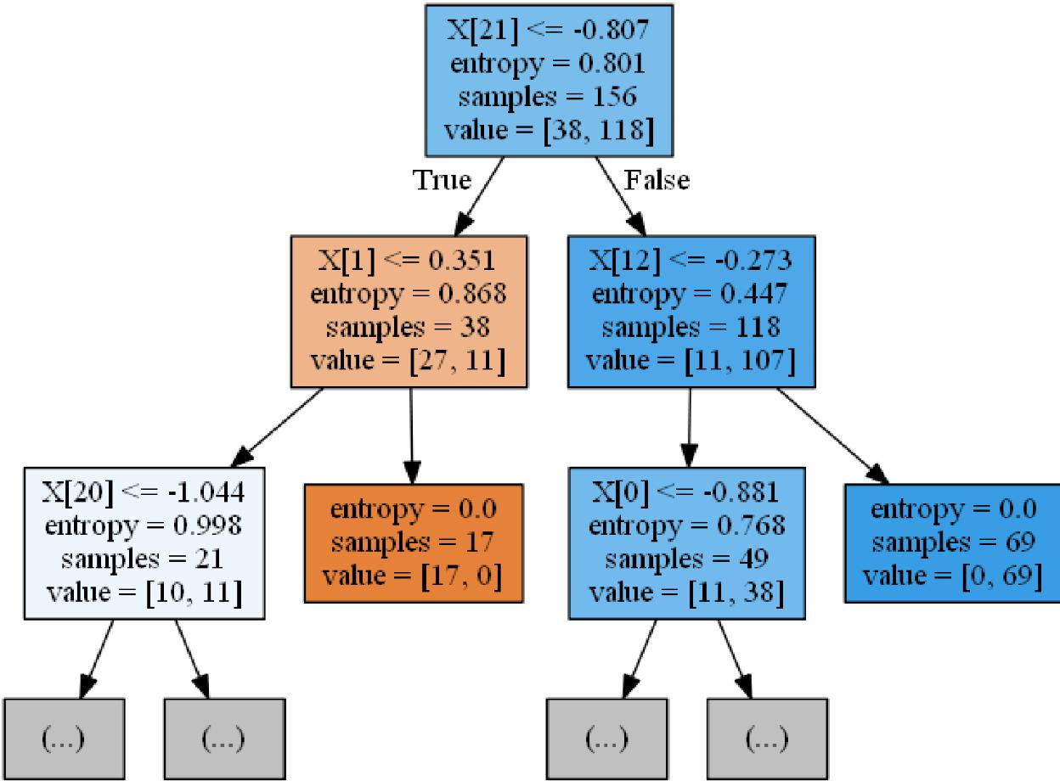

Fig-19 Tree of our model

This is a decision tree model of our dataset. In this tree in each node criterion “entropy”, samples and value of each variable is calculated

Criterion is a function, which measures the purity of nodes. Supported criteria are “Gini” for the Gini impurity and “entropy” for the information gain.

Lower the “entropy”, higher the homogeneity of nodes
FUTURE WORK AND CONCLUSION

5.1 GANNT CHART
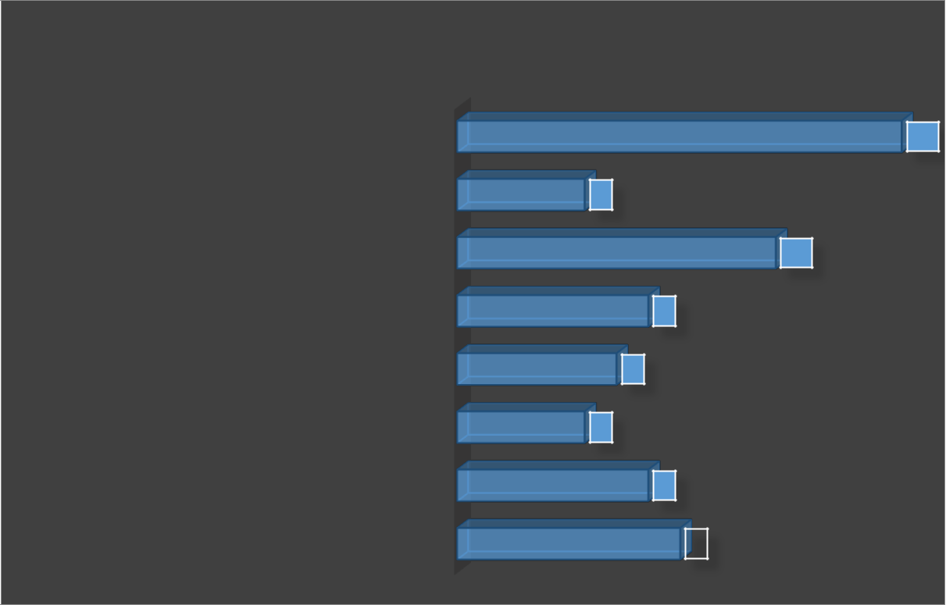

DURATION

FINAL REPORT WORK | 14
EVALUATING MODEL AND VISUALIZING DATA | 4
BUILDING A MACHINE LEARNING MODEL | 10
TRAINING AND TESTING DATA SETS | 6
DATA CLEANING AND DATA PREPROCESSING | 5
IMPORTING FEATURES OF VOICE SAMPLES INTO TABLE | 4
AND READING DATA SET | 4
ANALYSIS OF VOICE SAMPLES USING PRAAT | 6
SYNOPSIS |  | 7

Fig.20 Gannt chart

5.2 CONLUSION

- From this project we can see that accuracy of K-nearest neighbors is greater than the accuracy of Decision Tree Classification, so we can conclude from this observation that K-nearest neighbor is a better model among the three.

- Training accuracy is the accuracy you get if you apply the model on the training data, while Testing accuracy is the accuracy for the testing data.

  - Higher accuracy of testing data always results in a better model

- F1 score : In statistical analysis of binary classification, the F₁ score (also F-score or F-measure) is a measure of a test's accuracy

  - A good F1 score is approx. to 1(perfect precision and recall)

- Inertia is the sum of squared error for each cluster. Therefore, the smaller the inertia the denser the cluster. The Silhouette Score is from -1 to 1 and shows how close or far away the clusters are from each other and how dense the clusters are.

REFERENCES

[1] Geeks for Geeks, https://www.geeksforgeeks.org/

[2] Allerin, https://www.allerin.com/

[3] Research Gate, https://www.researchgate.net/

[4] Praat vocal tool kit, http://www.praatvocaltoolkit.com/

[5] Wikipedia, https://www.wikipedia.org/

[6] Towards Data Science, https://towardsdatascience.com/

[7] Analytics Vidhya, https://www.analyticsvidhya.com/

[8] Kaggle, https://www.kaggle.com/

[9] Sckit-learn, https://scikit-learn.org/stable/

